

**C E C S 4 6 0 | SPRING 2 0 1 9 | P R O J E C T # 1**

**T R A M E L B L A Z E**

**D O N G J A E S H I N**

**Table of Contents:**

1. **RTL Schematic**
2. **Description**
3. **Verilog / Assembly**
4. **TestFixture**
5. **Simulation**

**Description:**

The main goal of this project was to use mostly working counter from past class to change the main driver of it. This project uses Tramel Blaze, which is 16-bit Emulator for the 8-bit picoblaze. In order to create the ROM (read only memory), the assembly code is used to create it from the python code that is already given. The assembly code (.tba extension) drove to create .coe file. .coe file was then put into Xilinx vivado IP Memory create, to create the ROM for the tramel blaze.

The primary purpose of this project was getting use to the assembly code and tramel blaze.

**Simulation**

Decrement:

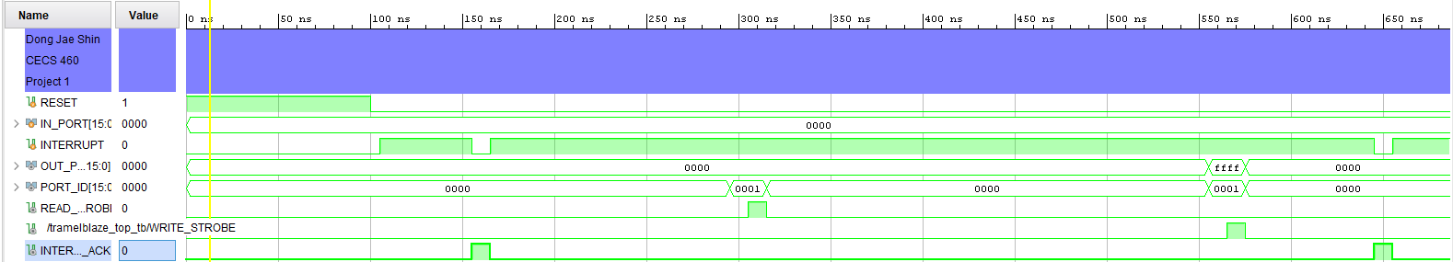

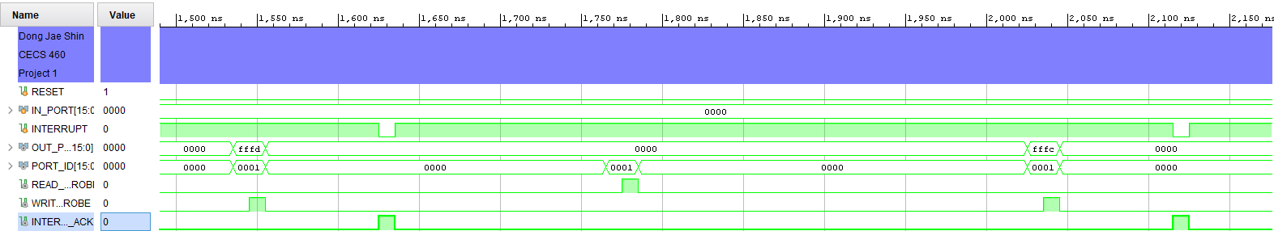

Increment:

